

DEPARTMENT OF COMPUTER SCIENCE & ENGINEERING

Lab Manual

Course Name : Computer Networks Lab
Course Code : CSE3131
Credits : 1 Credit
Session : July-November 2026

Course Coordinator: Dr. Shashvat & Dr. Ridhi Arora

Course Instructor: Dr. Sunita Singhal, Dr. Shashvat, Dr Praneet Saurabh, Dr. Usha Jain, Dr. Ridhi Arora, Dr. Sushama, Dr. Ankur Pandey, Dr. Sakshi Shringi, Dr. Rishi Kumar Srivastva
Signature

1

VISION & MISSION STATEMENTS

VISION:

To achieve Excellence in Computer Science & Engineering Education for Global Competency with Human Values

MISSION:

- Provide innovative Academic & Research Environment to develop competitive Engineers in the field of Computer Science Engineering
- Develop Problem-solving & Project Management Skills by Student Centric Activities & Industry Collaboration
- Nurture the Students with Social & Ethical Values

PROGRAM EDUCATIONAL OBJECTIVES
PEO1: Graduates will Demonstrate Professional Skills on Global Platform in Computer Science Engineering and Integrated Domains
PEO2: Graduates will Enhance Knowledge and Skills through Higher Studies and Lifelong Learning of New Computing Technologies
PEO3: Graduates will Provide Innovative Solutions to Drive Societal Advancement through Technology Entrepreneurship and Start-up

PROGRAM SPECIFIC OUTCOMES
PSO1. Design and develop optimized computational solutions using appropriate programming paradigms, contributing to sustainable development to ensure efficient resource utilization.

PSO2. Create intelligent or innovative solutions to real-world challenges by applying modern tools, software engineering practices, and emerging technologies.
PSO3. Process and communicate data effectively while ensuring software security, data privacy, and reliable data communication in practical applications.

PROGRAM OUTCOMES

Engineering graduates will be able to:

PO1: Engineering knowledge: Apply the knowledge of mathematics, science, engineering.

Fundamentals, and an engineering specialization to the solution of complex engineering problems.
PO2: Problem analysis: Identify, formulate, review research literature, and analyse complex engineering problems reaching substantiated conclusions using first principles of mathematics, natural sciences, and engineering sciences.
PO3: Design/development of solutions: Design solutions for complex engineering problems and design system components or processes that meet the specified needs with appropriate consideration for the public health and safety, and the cultural, societal, and environmental considerations.
PO4: Conduct investigations of complex problems: Use research-based knowledge and research methods including design of experiments, analysis and interpretation of data, and synthesis of the information to provide valid conclusions.
PO5: Modern tool usage: Create, select, and apply appropriate techniques, resources, and modern engineering and IT tools including prediction and modelling to complex engineering activities with an understanding of the limitations.
PO6: The engineer and society: Apply reasoning informed by the contextual knowledge to assess societal, health, safety, legal and cultural issues and the consequent responsibilities relevant to the professional engineering practice.
PO7: Environment and sustainability: Understand the impact of the professional engineering solutions in societal and environmental contexts, and demonstrate the knowledge of, and need for sustainable development.
PO8: Ethics: Apply ethical principles and commit to professional ethics and responsibilities and norms of the engineering practice.

PO9: Individual and team work: Function effectively as an individual, and as a member or leader in diverse teams, and in multidisciplinary settings.

PO10: Communication: Communicate effectively on complex engineering activities with the Engineering community and with society at large, such as, being able to comprehend and write effective reports and design documentation, make effective presentations, and give and receive clear instructions.
PO11: Project management and finance: Demonstrate knowledge and understanding of the engineering and management principles and apply these to one’s own work, as a member and leader in a team, to manage projects and in multidisciplinary environments.
PO12: Life-long learning: Recognize the need for, and have the preparation and ability to engage in independent and life-long learning in the broadest context of technological change.

COURSE OUTCOMES

At the end of the course, students will be able to:

CO1: Demonstrate the concepts of cisco packet tracer and network connecting devices. [level-2 Understand]

CO2: Develop the concepts of static and dynamic routing protocols. [level-3 Apply]

CO3: Make use of different topology and configuration. [level-3 Apply]

CO4: Construct of different protocols NAT, VLAN, DHCP. [level-3 Apply]

LIST OF EXPERIMENTS

S.NO. | Name of Experiment | Page No.
1 | Introduction to Net Sim and Packet tracer and networking device components | 8
2 | Network Utilities Commands: PING, NETSTAT, IPCONFIG, IFCONFIG, ARP, TRACE-ROU  NETSTAT, NSLOOKUP, PATHPING | 10
3 | Configuration of PC using packet tracer | 14
4 | Configuration of PC using Switch and Router | 18
5 | Router Mode, Switch/Router basic commands | 21
6 | Configuration of Static Routing Protocol | 24
7 | Configuration of RIPv1 and RIPv2 | 26
8 | Configuration of OSPF and troubleshooting | 28
9 | Configuration of VLAN and troubleshooting | 30
10 | NAT Protocol Configuration and troubleshooting | 33

ADDITIONAL EXPERIMENTS

S.NO. | Name of Experiment | Page No.
1 | Network Utilities Tools: NMAP, Wireshark, Network Scanner | 35
2 | Security: Security Threats and Vulnerabilities, Network Attacks, Network Attack Mitigation,  Security. | 39
3 | Case Study / Mini Project: Build a Small Network and Scale to Larger Networks, Troublesh  Scenarios | 44

PROGRAM -1:

- A . Aim: Introduction to Packet tracer and networking device components.

Theoretical Description: Packet Tracer is a powerful network simulation tool developed by Cisco, widely used for learning, teaching, and simulating network setups. It allows users to design, configure, and troubleshoot virtual networks. Packet Tracer offers a graphical user interface where users can drag and drop networking devices, configure them, and simulate various network scenarios without needing physical hardware.
Algorithm: Not Applicable Source Code: Not applicable
Description: Components of Networking Devices in Packet Tracer:

- Routers:

  - Routers are used to forward data packets between different networks. They operate at the network layer (Layer 3) of the OSI model and make decisions based on the destination IP address. Packet Tracer allows configuration of various router features like routing protocols (RIP, OSPF, EIGRP, BGP), NAT, ACLs, and more.
- Switches:

  - Switches are network devices that operate at the data link layer (Layer 2). They are used to connect devices within the same network (LAN) and make decisions based on MAC addresses. In Packet Tracer, switches can be configured for VLANs, STP, and trunking protocols.
- End Devices (PCs, Laptops, Servers):

  - End devices in Packet Tracer include PCs, laptops, and servers, which represent the user devices in a network. These can be connected to switches and routers, and users can configure IP addresses, simulate web services, FTP, DHCP, and more.
- Access Points and Wireless Devices:

  - Wireless routers and access points in Packet Tracer allow for the simulation of Wi-Fi networks. These devices enable wireless communication between PCs and other network devices, providing features such as SSID configuration, security protocols (WPA, WPA2), and DHCP services.
- Cables and Connectors:

  - Various types of cables (Ethernet, Fiber, Serial) can be used to connect networking devices in Packet Tracer. Each cable type has specific properties and limitations, allowing users to simulate accurate network topologies.
Output: This experiment demonstrates the basic use of Packet Tracer for configuring a simple network with basic components.
Conclusion: This experiment demonstrates the basic use of Packet Tracer for configuring a simple network with basic components.
Viva Questions:

- What is the role of the switch in the network?

- Explain the difference between a router and a switch.

- Discuss different types of cables and connectors.

- What is the difference between Bridge and Brouter?

Aim
1 B. To study the NetSim network simulation environment and understand the various networking device components available for designing and simulating computer networks.

Theoretical Description
NetSim is a comprehensive network simulation and emulation software developed by Tetcos. It is widely used in academia, research, and industry for designing, simulating, analyzing, and evaluating communication networks. NetSim enables users to create realistic network topologies, configure networking devices, analyze protocol behavior, and measure network performance without requiring physical hardware.
NetSim supports multiple networking technologies such as Ethernet, Wi-Fi (IEEE 802.11), MANET, LTE/5G, IoT, Sensor Networks, Satellite Networks, Software Defined Networks (SDN), and TCP/IP-based communication. It also provides detailed packet-level analysis, event tracing, graphical visualization, and performance metrics including throughput, delay, jitter, packet delivery ratio, and packet loss.
The graphical interface allows users to drag and drop network devices, configure protocol parameters, connect devices using different media, execute simulations, and analyze generated results.

Algorithm
Not Applicable

Source Code
Not Applicable

Description: Components of Networking Devices in NetSim
1. Routers
- Routers are Layer-3 networking devices responsible for forwarding packets between different networks based on IP addresses.
- NetSim supports static routing as well as dynamic routing protocols.
- Routers can be configured with multiple interfaces, routing tables, and protocol parameters.

2. Switches
- Switches operate at the Data Link Layer (Layer 2) and connect devices within a Local Area Network (LAN).
- They forward Ethernet frames based on MAC addresses.
- NetSim supports Ethernet switching, VLAN implementation, and switching behavior analysis.

3. End Devices (PCs, Servers, Workstations)
- End devices act as communication sources and destinations.
- These devices generate application traffic such as HTTP, FTP, Email, Voice, Video, and File Transfer.
- Users can configure IP addressing, applications, and transport layer protocols.

4. Wireless Access Points and Mobile Nodes
- Wireless devices simulate IEEE 802.11 Wi-Fi communication.
- Mobile nodes can move according to mobility models.
- Access Points provide wireless connectivity to laptops, smartphones, and IoT devices.

5. Links and Communication Media
NetSim provides different communication media, including:
- Ethernet Links
- Wireless Links
- Fiber Optic Links
- Point-to-Point Links
- Serial Links
Each communication medium has configurable bandwidth, propagation delay, packet loss probability, and transmission characteristics.

6. Internet Cloud
- Represents the Internet or Wide Area Network (WAN).
- Used for connecting geographically distributed networks.
- Supports Internet-based communication scenarios.

7. Traffic/Application Generator
NetSim provides several built-in applications:
- FTP
- HTTP
- Email
- Video Streaming
- Voice over IP (VoIP)
- Custom Traffic Generation
These applications generate realistic network traffic for protocol performance evaluation.

8. Simulation Engine
The simulation engine executes the designed network topology by processing discrete networ events.
It performs:
- Packet generation
- Routing
- Queue management
- Collision handling
- Protocol execution
- Performance metric calculation

9. Performance Analyzer
After simulation completion, NetSim automatically generates various performance statistics, including:
- Throughput
- End-to-End Delay
- Packet Delivery Ratio (PDR)
- Packet Loss
- Jitter
- Network Utilization
- Queue Length
- Energy Consumption (Wireless Networks)
These statistics are displayed as tables and graphs for easy analysis.

Procedure
- Launch the NetSim software.
- Create a new simulation workspace.
- Select the required network scenario.
- Drag and place networking devices (Router, Switch, PC, Server).
- Connect the devices using Ethernet links.
- Configure IP addresses and network parameters.
- Select the desired application traffic.
- Save the simulation project.
- Run the simulation.
- Observe packet transmission during execution.
- View the generated performance graphs and statistical reports.
- Analyze the simulation results.

Output
- Successful creation of a simple network topology in NetSim.
- Packet transmission between network devices.
- Performance graphs showing throughput, delay, packet delivery ratio, and packet loss.
- Simulation event logs and packet traces generated successfully.

Result
The basic network topology was successfully designed and simulated using NetSim. The communication between end devices was established, and the generated performance metrics were analyzed successfully.

PROGRAM -2:

Aim: To understand and use various network utility commands such as PING, NETSTAT, IPCONFIG, IFCONFIG, ARP, TRACE-ROUTE, NSLOOKUP, and PATHPING to monitor and
troubleshoot network configurations.

Theoretical Description:

Network utility commands are used to perform a variety of network-related operations. These commands allow users to check network status, troubleshoot issues, and gather information about devices and network routes. Here’s a brief description of each command:
- PING: Sends ICMP echo requests to a target IP address or hostname to verify connectivity.

- NETSTAT: Displays active connections, listening ports, routing tables, and network statistics.

- IPCONFIG (Windows) / IFCONFIG (Linux): Shows the IP configuration of network interfaces.

- ARP: Displays the ARP table (mapping of IP addresses to MAC addresses) used in a network.

- TRACE-ROUTE: Traces the route that packets take to reach a destination, displaying each hop.

- NSLOOKUP: Queries DNS servers for IP addresses corresponding to domain names.

- PATHPING: Combines PING and TRACE-ROUTE functionalities, showing packet loss and latency over each hop.
Algorithm: For each command, the algorithm generally follows this pattern:

- Open a Command Prompt (Windows) or Terminal (Linux).

- Run the command with necessary parameters (e.g., IP address, hostname).

- Observe the output for insights into network status or issues.

- Interpret the results based on what the command outputs (e.g., latency for PING, route for TRACE-ROUTE).
Source Code:

This section describes the syntax and examples for each network utility command:
- PING (Test connectivity): ping google.com

ping 192.168.1.1

- NETSTAT (View network connections): netstat -a (Shows all active connections) netstat -r (Displays routing table) netstat -e (Shows Ethernet statistics)
- IPCONFIG (Windows) / IFCONFIG (Linux): ipconfig (Windows)
ifconfig (Linux)

ipconfig /all (Displays detailed info in Windows)

- ARP (View ARP table):

arp -a

- TRACE-ROUTE (Trace packet path to a destination): tracert google.com (Windows)
traceroute google.com (Linux)

- NSLOOKUP (Query DNS):

nslookup google.com

- PATHPING (Check route and latency): pathping google.com
Output:

- PING:

Reply from 142.250.72.238: bytes=32 time=25ms TTL=55 Reply from 142.250.72.238: bytes=32 time=26ms TTL=55
- NETSTAT:

Active Connections:

Proto Local Address Foreign Address State

TCP 192.168.1.10:49704 142.250.72.238:https ESTABLISHED

- IPCONFIG (Windows):

Ethernet adapter Local Area Connection:

IPv4 Address: 192.168.1.10

Subnet Mask: 255.255.255.0

Default Gateway: 192.168.1.1

- IFCONFIG (Linux):

eth0 Link encap:Ethernet HWaddr 00:1C:C0:AE:B4:89

inet addr:192.168.1.10 Bcast:192.168.1.255 Mask:255.255.255.0

- ARP:

Interface: 192.168.1.10 --- 0x6

Internet Address Physical Address Type 192.168.1.1 00-14-22-01-23-45 dynamic
- TRACE-ROUTE:

Tracing route to google.com [142.250.72.238]

1 1 ms | 1 ms | 1 ms 192.168.1.1
2 15 ms | 15 ms | 14 ms 10.100.20.1
3 25 ms | 26 ms | 25 ms 142.250.72.238

- NSLOOKUP:

Server: dns.google Address: 8.8.8.8

Name: google.com Address: 142.250.72.238
- PATHPING:
Tracing route to google.com [142.250.72.238] Hop RTT Lost/Sent Address
1 <1ms 0/100 192.168.1.1

2 20ms 0/100 10.100.20.1

Conclusion: In this experiment, we explored different network utility commands that allow us to check network configurations, trace routes, and troubleshoot network issues. Each command serves a specific purpose, ranging from checking basic connectivity (PING) to analyzing network traffic (NETSTAT) and route discovery (TRACE-ROUTE, PATHPING). These tools are vital for network administrators to ensure proper network functionality and identify potential issues.
Viva Questions:

  - What is the function of the PING command?

  - Explain the difference between IPCONFIG and IFCONFIG.

  - How does the TRACE-ROUTE command help in identifying network issues?

  - What does the NSLOOKUP command do?

PROGRAM -3:

Aim: Star Topology using HUB and Switch, IP configuration of end devices, show command, copy command, password setting, hostname setting
Theoretical Description: A star topology for a Local Area Network (LAN) is one in which each node is connected to a central connection point, such as a hub or switch. Whenever a node tries to connect with another node then the transmission of the message must be happening with the help of the central node.
Algorithm:

Step 1: We have taken a switch and linked it to six end devices.
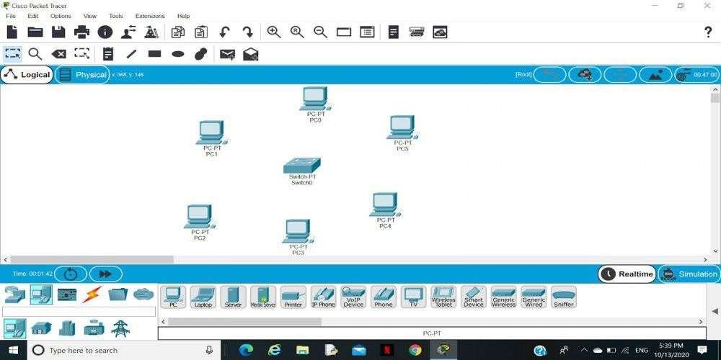

Step 2: Link every device with the switch.

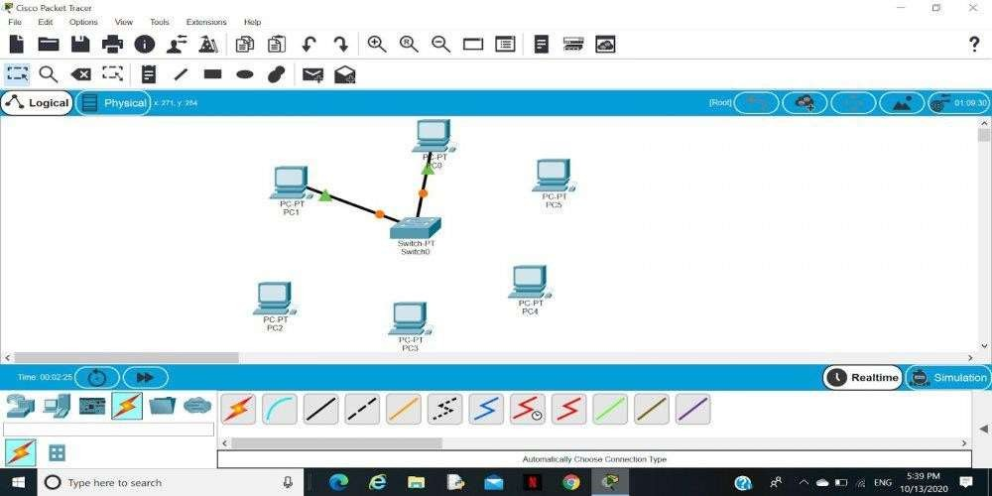

Step 3: Provide the IP address to each device.
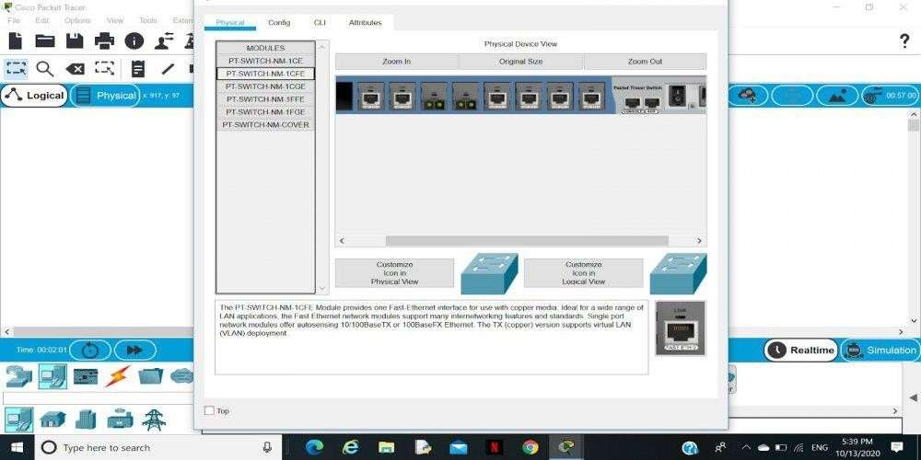

Step 4: Transfer message from one device to another and check the Table for Validation.
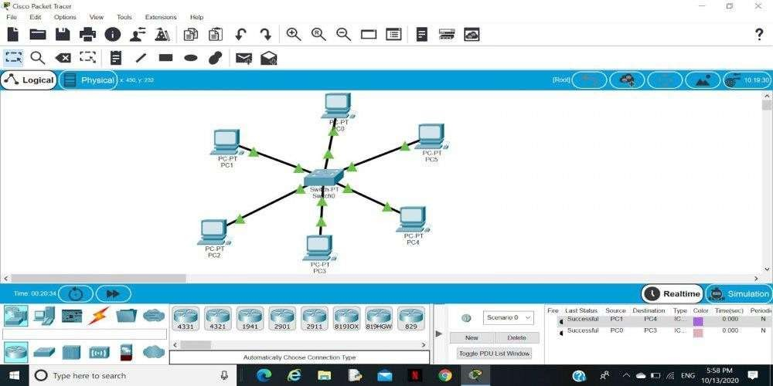
Now to check whether the connections are correct or not try to ping any device and the image below is doing the same.
To do ping one terminal of one device and run the following command: Command:
"ping ip_address_of _any_device"

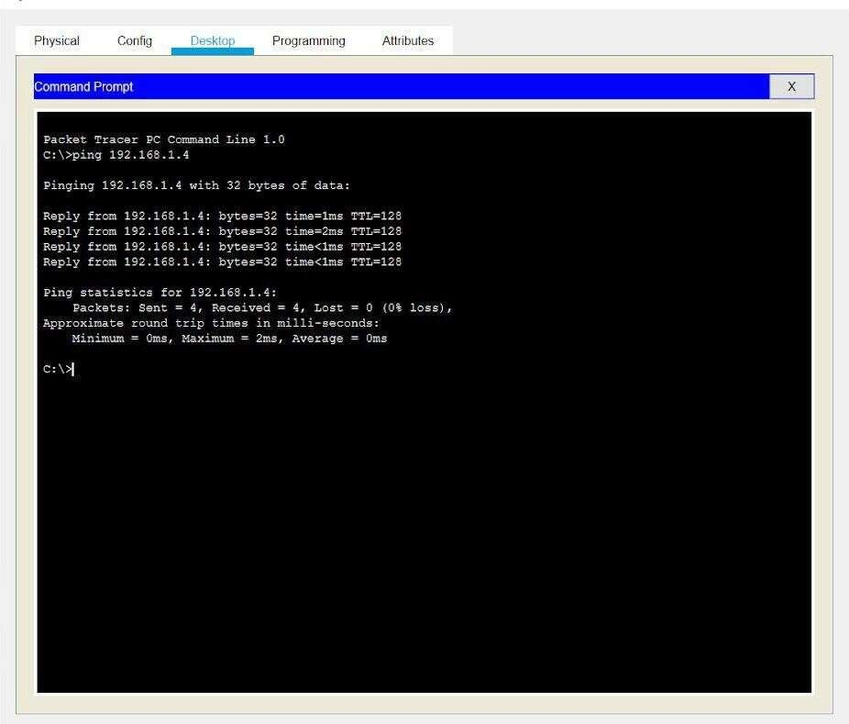
Output:

Conclusion:

In this experiment, we successfully simulated a Star Topology using both a HUB and Switch. We assigned IP addresses to the PCs connected in the network and verified communication using the ping command. Additionally, we configured the Switch by setting its hostname and password, and saved the configuration using the copy command. We demonstrated the use of basic show commands to view the switch status and configuration.
Viva Questions:

- How does a Switch forward packets compared to a HUB?

- How can you save the running configuration on a Cisco switch?

- What is the purpose of setting a password on a switch?

- How does subnetting help in dividing networks?

PROGRAM -4:

Aim: To configure Dynamic Host Configuration Protocol (DHCP) on a network device (such as a router) to dynamically assign IP addresses to devices connected to the network and verify the correct configuration.
Theoretical Description:

DHCP (Dynamic Host Configuration Protocol) is a network management protocol used to dynamically assign IP addresses and other related network configuration information (like subnet mask, gateway, DNS) to devices in a network. This eliminates the need for manually configuring each device with an IP address.
A DHCP server assigns IP addresses from a predefined range or pool of IP addresses to devices (clients) requesting an address. This system ensures efficient and automated distribution of IP addresses, reducing the risk of IP conflicts.
The basic process of DHCP includes four steps:

- DHCP Discover: The client broadcasts a request to find a DHCP server.

- DHCP Offer: The server responds with an IP address offer.

- DHCP Request: The client requests the offered IP address.

- DHCP Acknowledgment (ACK): The server confirms and assigns the IP address to the client.
Algorithm:

- Network Setup:

  - In Packet Tracer (or physical setup), place a router (or DHCP server), a switch, and several end devices (PCs, laptops).
  - Connect the router to the switch, and connect the end devices to the switch using straight-through cables.
- DHCP Configuration on the Router:

  - Access the router's CLI.

  - Enter global configuration mode and configure a DHCP pool with a range of IP addresses.

- Exclude Specific IP Addresses (Optional):

  - If certain IPs (like the router itself) should not be assigned dynamically

- IP Configuration on End Devices:

  - On the PCs connected to the network, go to the Desktop tab in Packet Tracer, open IP Configuration, and select DHCP.
  - The PCs should automatically obtain an IP address from the DHCP server.

- Verification:

  - On the router, use the following command to verify the leased IP addresses:

    - Router# show ip dhcp binding

Output:

- PC IP Configuration (Automatically Assigned):

  - IP Address: 192.168.1.11

  - Subnet Mask: 255.255.255.0

  - Default Gateway: 192.168.1.1

  - DNS Server: 8.8.8.8

- DHCP Binding Output (On Router):

  - IP address Client-ID/Lease expiration Type

  - 192.168.1.11 0001.4a55.a3b7 Automatic

  - 192.168.1.12 0002.4b67.fad9 Automatic

- DHCP Show Command Output:

  - Router# show ip dhcp binding

  - Router# show ip dhcp pool

  - Pool MY_POOL :

  - Utilization: 2 addresses in use, 246 available

  - Subnet size: 256

Conclusion: In conclusion, DHCP is a technology that simplifies network setup by automatically assigning IP addresses and network configurations to devices. While DHCP offers convenience, it’s important to manage its security carefully. Issues such as IP address exhaustion, and potential data access through DNS settings highlight the need for robust security measures like firewalls and VPNs to protect networks from unauthorized access and disruptions. DHCP remains essential for efficiently managing network connections while ensuring security against potential risks.
Viva Questions:

- What is the role of a DHCP server in a network?

- Explain the DHCP Discover and DHCP Offer processes.

- What is the significance of the default-router command in DHCP configuration?

- Why would you use the ip dhcp excluded-address command in DHCP configuration?

PROGRAM -5:

Aim: To understand the modes of operation in a Router and explore basic Router and Switch commands for configuring and managing network devices.
Theoretical Description:

A Router operates in various modes, each allowing different levels of configuration and command execution. The most common modes in a router are:
- User EXEC Mode: This is the initial mode when accessing the router, which has limited functionality, mainly for viewing basic information.
  - Prompt: Router>
- Privileged EXEC Mode: Provides access to all the show commands, debugging, and basic device management commands. You can also enter global configuration mode from here.
  - Prompt: Router#
  - Command to enter: enable
- Global Configuration Mode: Used to make system-wide configurations. You can configure interfaces, routing protocols, and other features.
  - Prompt: Router(config)#
  - Command to enter: configure terminal
- Interface Configuration Mode: Used to configure the individual interfaces (ports) of the router.

  - Prompt: Router(config-if)#
  - Command to enter: interface [type/number] (e.g., interface GigabitEthernet0/0)
Switches also have a similar hierarchy of command modes and allow management through VLANs, port configurations, etc.
Algorithm:

- Access the Router or Switch:

  - Open a terminal or console session to the Router/Switch.

- Switch to Privileged EXEC Mode:

  - Enter the enable command to switch from user mode to privileged EXEC mode.

- Enter Global Configuration Mode:

  - Use the configure terminal command to enter global configuration mode.

- Configure Interfaces (For Routers):

  - Use interface commands to configure IP addresses, enable/disable interfaces, etc.

  - Example: interface GigabitEthernet0/0

- View Status and Information:

  - Use commands like show ip interface brief, show running-config, etc., to view current configurations.
- Basic Switch Commands:

  - Set the hostname, password, and manage VLANs.

Output:

- Router Hostname Configuration: MyRouter(config)# hostname MyRouter MyRouter#
- Interface IP Configuration:

MyRouter(config-if)# ip address 192.168.1.1 255.255.255.0 MyRouter(config-if)# no shutdown
- Switch VLAN Configuration:

MySwitch# show vlan brief

VLAN Name Status Ports

10 Sales |  |  | active | Fa0/1
4. Interface | Status | on | Router:

MyRouter# show ip interface brief

Interface IP-Address OK? Method Status Protocol GigabitEthernet0/0 192.168.1.1 YES manual up up
Conclusion: In this experiment, we explored the different modes of a router and basic switch commands. We configured a router's hostname, IP address, and interfaces, and also set up VLANs on a switch.
Viva Questions:

- What is the difference between User EXEC Mode and Privileged EXEC Mode?

- Why do we use the no shutdown command after configuring an interface?

- What is the purpose of setting a default gateway on a router?

PROGRAM -6:

Aim: To configure Static Routing on a network using routers, ensuring data packets are directed to the correct destination networks via predefined paths.
Theoretical Description: Static routing is a routing technique in which a network administrator manually adds routes to a routing table. Unlike dynamic routing protocols, static routing does not adjust automatically to network topology changes. It is commonly used in small, simple networks or where specific routes need to be enforced due to security or performance requirements.
Algorithm:

- Network Setup:

  - Design the network topology with at least two routers, connected via serial or Ethernet links, along with some end devices (PCs or switches) connected to each router.
- Access Each Router's CLI:

  - Open the terminal on each router and switch to Privileged EXEC Mode using the enable command.
- Assign IP Addresses to Router Interfaces:

  - Configure IP addresses for the router interfaces that connect to each other and to the local networks.
- Define Static Routes:

  - For each network, define the next-hop router IP address (or exit interface) for routing traffic.
- Test Connectivity:

  - Use the ping and traceroute commands to verify that the devices in different networks can communicate.
Output:

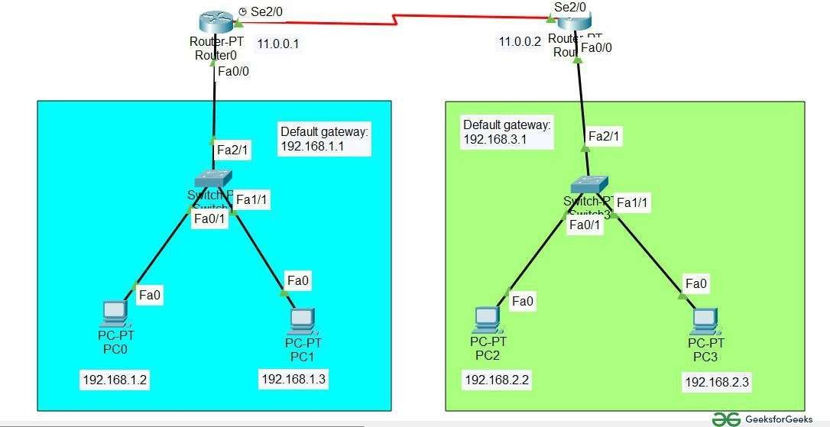

Conclusion: In this experiment, we successfully configured Static Routing between two routers. By defining static routes, we manually instructed each router on how to reach the other network. This allowed communication between devices in different networks.
Viva Questions:

- What is the difference between static routing and dynamic routing?

- What are the advantages and disadvantages of static routing?

- Explain the next-hop IP address in static routing.

- How can you verify that a static route has been correctly configured on a router?

PROGRAM -7:

Aim: To configure Routing Information Protocol (RIP) on a set of routers to enable dynamic routing between multiple networks.
Theoretical Description: Routing Information Protocol (RIP) is a dynamic routing protocol used in local and wide area networks. RIP is a distance-vector routing protocol that uses hop count as the metric for path selection. RIP has two versions, RIPv1 and RIPv2, with some key differences:
- RIPv1: A classful routing protocol that does not support subnet information and works without sending subnet masks, making it unsuitable for Variable Length Subnet Masking (VLSM) or Classless Inter-Domain Routing (CIDR).
- RIPv2: A classless routing protocol that supports subnet masks and includes VLSM and CIDR support. RIPv2 also supports authentication and multicast for route updates.
Algorithm:

  - Setup Network Topology:

    - Design a network with at least two or more routers connected via serial or Ethernet links. Configure IP addresses on each router’s interface.
  - Enter Global Configuration Mode:

    - On each router, access the command-line interface (CLI) and switch to privileged EXEC mode.
  - Enable RIP:

    - Enable RIP on each router and specify the version (RIPv1 or RIPv2).
  - Advertise Networks:

    - For each router, advertise the connected networks so RIP can propagate the routes dynamically.
  - Verify Configuration:

    - Check that the routers have dynamically learned the routes from other routers using the RIP protocol.
Output:

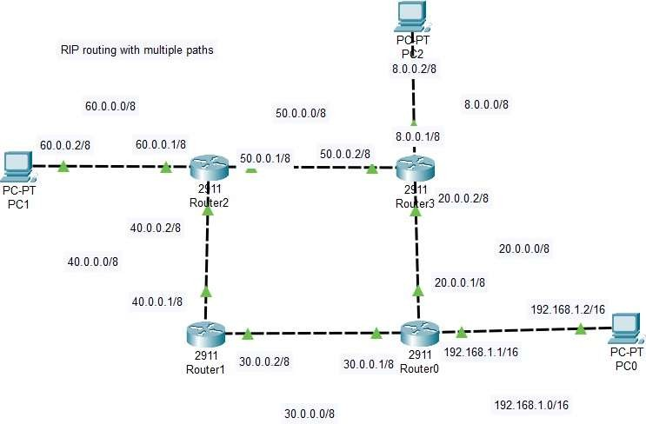

Conclusion: In this experiment, we configured both RIPv1 and RIPv2. RIPv1 does not support subnetting, which limits its usefulness in modern networks. RIPv2, however, is classless and supports VLSM and CIDR, making it more flexible. By configuring RIP, we were able to dynamically propagate routes between routers and verify communication between different networks.
Viva Questions:

- What is the maximum hop count allowed by RIP?

- Explain the differences between RIPv1 and RIPv2.

- Why is RIPv1 considered a classful routing protocol?

- What are the limitations of RIPv1 in modern networks?

PROGRAM -8:

Aim: To configure Open Shortest Path First (OSPF) routing protocol on multiple routers in a network and troubleshoot common OSPF configuration issues.
Theoretical Description: OSPF (Open Shortest Path First) is a link-state routing protocol used in Internet Protocol (IP) networks to find the best path for data to travel. OSPF is more efficient and scalable compared to distance-vector routing protocols like RIP. It is widely used in both small and large enterprise networks and is part of the Interior Gateway Protocol (IGP) suite.
Algorithm:

- Define Network Topology:

  - Create a network with at least two routers connected via serial or Ethernet links. Each router should be connected to end devices like PCs or switches.
- Configure IP Addresses:

  - Assign IP addresses to all router interfaces connecting them to each other and to local networks.
- Enable OSPF:

  - On each router, enable OSPF, assign a process ID, and specify the OSPF area (typically Area 0).
- Advertise Networks:

  - Use the network command to define the networks that OSPF will advertise to other routers.
- Verify and Troubleshoot:

  - Check OSPF neighbors, routing tables, and troubleshoot any connectivity issues.

Output:

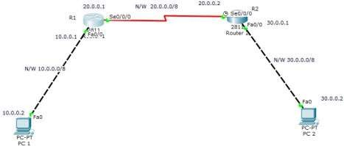

Conclusion: In this experiment, we successfully configured OSPF on multiple routers and dynamically propagated routes between them. OSPF's link-state nature ensures fast convergence and efficient path selection based on the cost metric. Additionally, we troubleshooted common OSPF configuration errors, such as incorrect network statements, mismatched OSPF timers, and neighbor adjacency issues.
Viva Questions:

- What is the main difference between OSPF and RIP?

- How does OSPF calculate the best route?

- What is the purpose of the OSPF area and why is Area 0 important?

- Explain the difference between OSPF broadcast and non-broadcast networks.

- What is the hello and dead interval in OSPF, and why are they important?

PROGRAM -9:

Aim: To configure VLAN (Virtual Local Area Network) on a switch and verify its functionality by assigning ports to different VLANs. Additionally, troubleshoot VLAN-related issues to ensure proper network segmentation.
Theoretical Description: VLAN (Virtual Local Area Network) is a logical grouping of devices within a network that allows segmentation of a network into different broadcast domains. This segmentation enhances security, improves network performance, and simplifies network management by grouping devices logically instead of physically.
A VLAN operates at Layer 2 (Data Link Layer) of the OSI model, and each VLAN acts as a separate network segment, even if the devices are connected to the same physical switch. Devices in the same VLAN can communicate with each other, while devices in different VLANs require a Layer 3 device (like a router) to communicate.
Common VLAN types:

  - Default VLAN: All switch ports belong to VLAN 1 by default.

  - Data VLAN: Carries user-generated traffic (e.g., VLAN 10 for HR, VLAN 20 for Sales).

  - Voice VLAN: Carries voice traffic, typically prioritized over data traffic.

  - Management VLAN: Used for network management traffic (e.g., SSH, Telnet).

Algorithm:

- Define Network Topology:

  - Identify the switch and end devices (PCs) that need to be assigned to different VLANs.

- Access Switch:

  - Log into the switch and enter global configuration mode.

- Create VLANs:

  - Create and name VLANs as per the network requirements.

- Assign Ports to VLANs:

  - Assign specific switch ports to the desired VLANs.

- Configure Trunk Ports (Optional):

  - If multiple switches are connected, configure trunking on the switch-to-switch link to allow traffic from multiple VLANs to pass through.
- Verify VLAN Configuration:

  - Verify VLANs and ensure devices within the same VLAN can communicate.

- Troubleshoot VLAN Issues:

  - Check the VLAN configuration for any misconfigured ports or VLAN assignments.

Output:

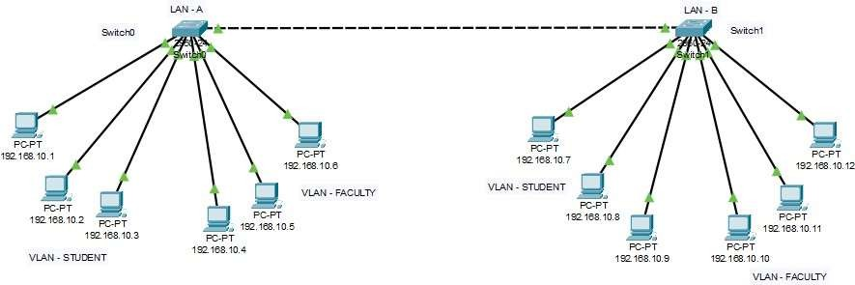

Conclusion: In this experiment, we successfully configured VLANs on a switch, segmented the network into different broadcast domains, and tested communication between devices within the same VLAN. We also learned to troubleshoot common VLAN issues such as misconfigured ports and trunk links.
Viva Questions:

- How does a switch handle VLAN traffic?

- What is the difference between an access port and a trunk port?

- How do you configure inter-VLAN routing?

- What command would you use to verify VLANs configured on a switch?

- Why is trunking necessary when connecting multiple switches?

- What is the difference between tagged and untagged VLAN traffic?

PROGRAM -10:

Aim: To implement and analyze the Network Address Translation (NAT) protocol in a simulated network environment to understand its configuration, operation, and troubleshooting techniques.
Theoretical Description: Network Address Translation (NAT) is a technique used in networking to translate private (non-routable) IP addresses to a public (routable) IP address and vice versa. NAT is crucial for conserving the limited number of public IP addresses and enhancing security by hiding internal IP addresses from external networks.
Types of NAT:

- Static NAT: A fixed mapping between a private IP and a public IP, allowing external devices to access internal servers.
- Dynamic NAT: Maps private IPs to a public IP from a defined pool.

- PAT (Port Address Translation): Allows multiple devices on a local network to be mapped to a single public IP address, differentiated by unique port numbers.
Key Concepts:

  - NAT Inside: Refers to the internal network.

  - NAT Outside: Refers to the external network (internet).

  - Translation Table: Maintains the mapping between private and public IP addresses.

Algorithm:

    - Define Access List:

      - Create an access list to identify internal IPs that should be translated.

    - Configure NAT Pool (for Dynamic NAT):

      - Define a pool of public IP addresses for translation.

    - Specify Interfaces:

      - Configure the router interfaces as NAT inside or outside.

    - Associate Access List with NAT Configuration:

      - Link the access list to the NAT pool or define overload for PAT.

    - Test Connectivity:

      - Check if devices can access external networks and whether NAT translations are happening.
    - Troubleshoot if Necessary:

      - Use commands to check NAT translations and statistics to diagnose issues.

Output:

  - Successful translation of private IP addresses to a public IP address.

  - Connectivity from devices on the private network to external networks.

  - Display of NAT translation table showing active mappings between internal and external addresses.
Conclusion:

The implementation of NAT demonstrates its critical role in modern networking by enabling multiple devices to share a single public IP address while providing security by masking internal IP addresses. Understanding NAT configuration and troubleshooting enhances network management skills, ensuring efficient operation and connectivity in various network scenarios.
Viva Questions:

- What is the primary purpose of NAT in networking?

- Explain the difference between static NAT and dynamic NAT.

- How does PAT work, and why is it useful?

- What are the advantages and disadvantages of using NAT?

- Describe the steps involved in configuring NAT on a router.

PROGRAM -11:

Aim: To discover hosts and services on a network and assess security by identifying open ports and running services.
Theoretical Description

Nmap (Network Mapper) is an open-source tool designed for network exploration and security auditing. It works by sending specially crafted packets to the target host and analyzing the responses. It can be used to perform tasks such as host discovery, port scanning, and OS detection.
Algorithm

- Input Target(s): Specify the IP address or range of IPs to scan.

- Send Packets: Send various types of packets (TCP, UDP) to the target.

- Receive Responses: Analyze the responses to determine the state of ports (open, closed, filtered).
- Identify Services: Optionally probe open ports to identify running services and versions.

- Output Results: Generate a report of the findings.

Output

  - List of active devices and their IP addresses.

  - Open ports and their states (open, closed, filtered).

  - Identified services and versions running on open ports.

  - Operating system and hardware details of the scanned devices.

Conclusion

Nmap is an essential tool for network administrators and security professionals. It provides valuable insights into network configuration and security posture, enabling proactive management and vulnerability assessment.

2. Wireshark

Aim: To capture and analyze network traffic in real-time for troubleshooting, protocol analysis, and security monitoring.
Theoretical Description

Wireshark is a widely used network protocol analyzer that captures packets traversing a network interface and decodes the data for analysis. It supports hundreds of protocols and allows users to view the details of each packet, including headers and payload data.
Algorithm

- Select Network Interface: Choose the network interface to capture traffic from.

- Start Capture: Begin capturing packets on the selected interface.

- Apply Filters: Optionally apply capture or display filters to focus on specific traffic.

- Analyze Packets: Inspect captured packets for relevant information, including protocols and payloads.
- Export Data: Save or export captured data for further analysis if needed.

Output

  - Real-time display of network packets with detailed information.

  - Statistics about captured traffic, including protocol distribution.

  - Exported data files in formats like PCAP for further analysis.

Conclusion

Wireshark is a powerful tool for network analysis, enabling users to troubleshoot issues, monitor network performance, and analyze security incidents. Its detailed packet-level analysis helps in understanding complex network behaviours.

3. Network Scanner (General)

Aim: To discover devices on a network, identify their IP and MAC addresses, and assess the services running on them.
Theoretical Description

Network scanners are tools used to identify devices on a network by sending requests and analyzing responses. They help in mapping the network topology, checking for unauthorized devices, and identifying vulnerabilities.
Algorithm

- Specify IP Range: Define the IP address range to scan.

- Send Discovery Requests: Send ARP requests or ICMP pings to each IP address in the range.
- Receive Responses: Collect responses from devices indicating their presence and status.

- Scan Ports (Optional): For each discovered device, perform port scanning to check for open ports.
- Output Results: Compile and present the list of discovered devices.

Output

  - List of active devices with their IP addresses and MAC addresses.

  - Identified open ports and services for each device (if port scanning is performed).

  - Basic information about device manufacturers (if MAC addresses are resolved).

Conclusion

Network scanners play a crucial role in network management, security auditing, and troubleshooting. They provide a clear view of the network landscape, enabling administrators to monitor for unauthorized devices and assess vulnerabilities.

Viva Questions

- What is the primary purpose of Nmap, and how does it work?

- How does Wireshark differ from Nmap in terms of functionality?

- Describe the steps involved in using a network scanner.

- What types of information can Nmap provide during a scan?

- How can you filter packets in Wireshark, and why is this useful?

- Explain the significance of open ports in network security assessments.

- What are some ethical considerations when using these network utility tools?

- Discuss a scenario where Wireshark would be more beneficial than Nmap.

- How can network utilities assist in penetration testing?

- What are the limitations of using these tools in a corporate environment?

PROGRAM -12:

  - Security Threats and Vulnerabilities

Aim: To identify and understand various security threats and vulnerabilities that can affect computer networks and devices, and to develop strategies for mitigating these risks.
Theoretical Description

Security threats are potential dangers that can exploit vulnerabilities in a network or device to compromise its confidentiality, integrity, or availability. Vulnerabilities are weaknesses in systems that can be exploited by threats. Common threats include malware, phishing, DDoS attacks, and insider threats.
Algorithm

- Identify Assets: Determine what needs to be protected (data, devices, networks).

- Assess Vulnerabilities: Conduct vulnerability assessments to identify weaknesses in the system.

- Analyze Threats: Identify potential threats that could exploit vulnerabilities.

- Evaluate Impact: Assess the potential impact of these threats on the organization.

- Prioritize Risks: Rank vulnerabilities based on their severity and likelihood of exploitation.

Output

  - A list of identified vulnerabilities and associated threats.

  - Risk assessment report outlining potential impacts and likelihood.

  - Prioritized list of security measures to mitigate identified risks.

Conclusion

Understanding security threats and vulnerabilities is crucial for organizations to protect their assets. Regular assessments and proactive measures help to minimize risks and enhance overall security.

  - Network Attacks

Aim: To categorize and describe various types of network attacks that threaten the integrity, availability, and confidentiality of information.
Theoretical Description

Network attacks are attempts to breach a network's security to access, steal, or disrupt data. Common types of network attacks include:
    - Denial of Service (DoS): Overwhelming a service with traffic to make it unavailable.

    - Man-in-the-Middle (MitM): Intercepting and altering communications between two parties.

    - Phishing: Deceiving users into providing sensitive information.

    - Malware: Malicious software that can disrupt operations, steal data, or damage systems.

Algorithm

- Identify Attack Types: List different network attack types.

- Analyze Attack Mechanisms: Study how each attack is carried out.

- Assess Impact: Evaluate the impact of each attack type on systems and data.

- Document Examples: Provide real-world examples of each attack type.

Output

  - Comprehensive report detailing various network attack types.

  - Examples and case studies highlighting the impact of these attacks.

  - Risk assessments associated with each attack type.

Conclusion

Awareness of network attacks is essential for organizations to implement appropriate defenses. Understanding how attacks work enables proactive security measures to safeguard network infrastructure.

  - Network Attack Mitigation

Aim: To develop strategies and implement measures to protect networks against potential attacks.
Theoretical Description

Network attack mitigation involves implementing security measures to reduce the risk and impact of attacks. Techniques include firewalls, intrusion detection/prevention systems (IDS/IPS), and regular software updates.
Algorithm

- Identify Vulnerabilities: Conduct vulnerability assessments to pinpoint weaknesses.

- Implement Security Controls: Apply firewalls, IDS/IPS, and anti-malware solutions.

- Develop Incident Response Plan: Create a plan to address and recover from security incidents.
- Regular Monitoring: Continuously monitor network traffic for suspicious activities.

- Conduct Training: Educate staff on security best practices to prevent attacks.

Output

  - Security policy documentation outlining mitigation strategies.

  - Incident response plan for addressing potential security breaches.

  - Monitoring reports highlighting suspicious activities and responses.

Conclusion

Effective mitigation strategies are essential for minimizing the risks associated with network attacks. Continuous monitoring and employee training are key components of a robust security posture.

  - Device Security

Aim: To ensure that individual devices connected to a network are secure and protected against vulnerabilities and attacks.
Theoretical Description

Device security involves protecting hardware and software from unauthorized access, misuse, or damage. This includes implementing security measures like antivirus software, encryption, and secure configurations.
Algorithm

- Identify Devices: Inventory all devices connected to the network.

- Assess Security Posture: Evaluate each device for security vulnerabilities.

- Apply Security Measures: Implement security measures such as:

  - Antivirus and antimalware software
  - Regular software updates and patch management
  - Encryption of sensitive data
  - Secure configurations (e.g., changing default passwords)
- Monitor Device Security: Regularly review device logs and security alerts.

- Educate Users: Provide training on secure device usage and practices.

Output

- Security assessment reports for each device.

- Implementation of security measures and configurations.

- User training materials on device security best practices.

Conclusion

Securing individual devices is crucial for the overall security of a network. Regular assessments and proactive security measures ensure that devices remain resilient against threats.
Viva Questions

- What are the main types of security threats faced by networks?

- How do vulnerabilities differ from threats in the context of network security?

- Explain the concept of a Denial of Service (DoS) attack and its impact.

- What are some effective strategies for mitigating network attacks?

- How can organizations protect their devices from security threats?

- What role does user education play in enhancing security?

- Describe the importance of an incident response plan in network security.

- What tools can be used to detect and prevent network attacks?

Program:13

Aim: Case Study / Mini Project: Build a Small Network and Scale to Larger Networks, Troubleshooting Scenarios.
Case Study:

Building and Scaling a Small Network to a Large Network with Troubleshooting

Objective:

To design a small network, scale it to a larger network, and troubleshoot common issues that arise during network expansion.
Scenario:

A small startup requires a network for its office consisting of a few computers, a router, and a switch. As the company grows, the network must scale to accommodate new departments, additional users, and servers while ensuring reliable communication, security, and performance.
Phase 1: Small Network Design

The initial network was designed with the following components:

- One Router: Connected to the internet via a broadband modem.

- One Switch: Connected to two PCs and the router.

- PCs: Two employees need internet access and file sharing capabilities.

Configuration:

- The router was configured to assign IP addresses via DHCP.

- PCs were connected through the switch, and the network was tested using ping to verify connectivity.
- Internet access was successfully established, and file sharing between PCs was tested.

Phase 2: Scaling the Network

As the company grew, the network needed to support:

- Two additional departments: Each requiring its own subnet.

- A File Server: For centralized data storage and sharing.

- Backup Router: For redundancy and failover.

- Additional Devices: Including 20 more PCs, printers, and networked devices.

Scaling Approach:

- Routing Protocol (OSPF) was implemented to facilitate communication between different subnets.
- VLANs were set up to segment traffic between departments.

- File Server was added, and secure access was configured.

- Redundancy was achieved by adding a backup router, ensuring continuous internet access in case of a failure.
Phase 3: Troubleshooting

Several common issues were simulated during scaling, and solutions were implemented:

- Connectivity Issue: One PC lost connectivity due to an incorrect VLAN assignment. Troubleshooting with ping and traceroute helped identify the issue, and the PC was reassigned to the correct VLAN.
- IP Conflict: Two devices were assigned the same IP address, causing network disruptions. This was resolved by manually reassigning IPs and adjusting DHCP scope.
- Slow Network Performance: Excessive traffic on a single link caused delays. Quality of Service (QoS) settings were configured to prioritize important traffic, improving performance.
Outcome:

The network scaled smoothly, supporting over 50 devices across multiple departments with secure, high-performance communication. Redundancy ensured uninterrupted service, and troubleshooting processes kept the network running optimally.
Conclusion:

This case study demonstrates the challenges of scaling a small network to a larger one, highlighting the importance of proper design, configuration, and troubleshooting techniques.

The project provided a practical understanding of how to manage networks efficiently while maintaining performance and security.

